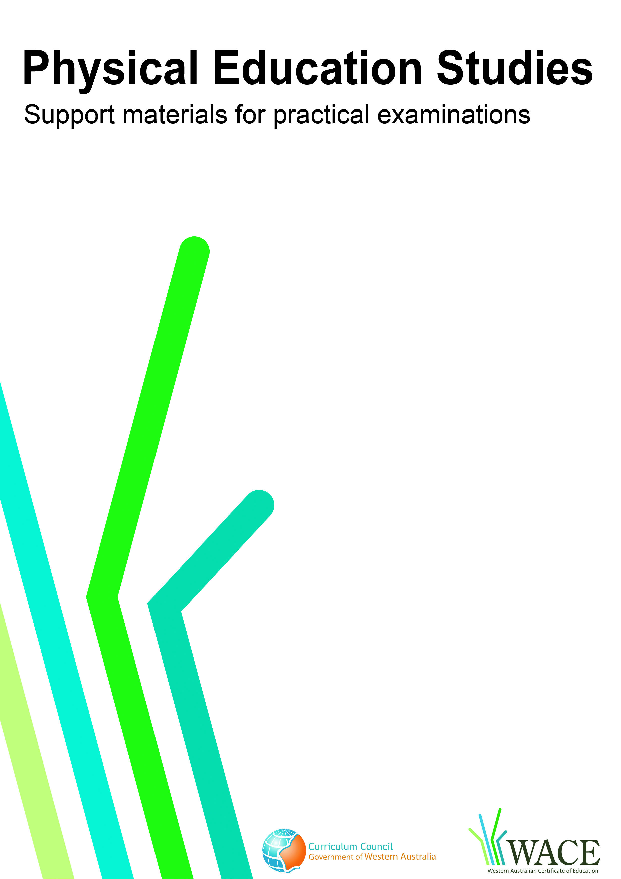

Badminton

© Curriculum Council, 2011
This document—apart from any third party copyright material contained in it—may be freely copied, or communicated on an intranet, for non-commercial purposes by educational institutions, provided that it is not changed in any way and that the Curriculum Council is acknowledged as the copyright owner.
Copying or communication for any other purpose can be done only within the terms of the Copyright Act or by permission of the Curriculum Council.
Copying or communication of any third party copyright material contained in this document can be done only within the terms of the Copyright Act or by permission of the copyright owners.
Version 5

Introduction
The purpose of these materials is to support teachers and candidates in preparation for the Physical Education Studies practical examination.

Skills set for badminton
These materials outline the examinable skills set for badminton. Five (5) of the skills, selected by the examination panel, will be examined and these will be communicated to the candidates at the commencement of the examination. Unless specified, candidates will be expected to have the ability to execute skills on both the forehand and backhand sides.

Observation points
Observation points are provided for each skill in the skills set. They are provided for the purpose of teaching and coaching and are designed to assist examination candidates in their personal skill development.

Examination drills
The examination will contain a number of drills through which the selected skills will be assessed. These materials outline a number of drills indicative of the types of drills in which the candidates will participate during the examination and may form part of a teaching program.

Tactical framework
In the conditioned performance section of the examination, candidates will participate in a modified competitive situation, which will be based on some of the tactical problems in badminton. The tactical problems for the examination are outlined in the tactical framework and will be selected by the examination panel. The skills that provide the basis for the solutions to these tactical problems are also included in the framework.

In the conditioned performance section of the badminton examination, students will be assessed on the execution of skills, setting up an attack, court positioning and decision making that effectively solve the tactical problems presented by the modified competitive situation.

CONTENTS | PAGE NUMBER
Badminton skills set | 5
Skills set and observation points | 6
Badminton drills | 12
Drill descriptions | 13
Tactical framework | 31

Skill number | Name of skill | Page number
1 | High singles serve | 6
2 | Low serve | 6
3 | Flick serve | 7
4 | Return of low serve | 7
5 | Forehand overhead drop shot | 8
6 | Backhand overhead cross-court drop shot | 8
7 | Forehand smash | 8
8 | Overhead clear | 9
9 | Forehand net attack shot | 9
10 | Underarm net tumble shot | 10
11 | Underarm clear | 10
12 | Drive | 11

1. HIGH SINGLES SERVE
Preparation | Execution | Completion
- Stand mid-court near the centre line  - Body slightly side-on to the net  - Non-racquet foot forward  - Racquet held up behind the body  - Shuttle held in cup style (C-shape) out in front of leading foot | - Contact point in front of leading foot  - Transfer body weight from racquet foot to non-racquet foot  - Arm pronates on the forward upward swing  - Trajectory: Shuttle travels high and deep | - Follow through in the direction of the shot  - Shuttle lands on or in back tramlines
2a LOW SERVE - FOREHAND
Preparation | Execution | Completion
- Body slightly side-on to the net with non-racquet foot forward  - Body weight evenly balanced  - Shortened forehand grip  - Racquet commences behind/side of the body  - Shuttle held in cup style (C-shape) out in front of leading foot | - Shuttle guided over the net with a pushing movement  - Contact point in front of the body  - Trajectory: shuttle skims the net | - Minimum follow through with racquet head facing direction of the shot  - Shuttle lands in the target area located in the front centre corner of the service court
2b. LOW SERVE - BACKHAND
Preparation | Execution | Completion
- Stand near ‘T’  - Body square to net with racquet foot forward  - Shortened backhand grip  - Shuttle held by fingertips in front of the body with racquet head down | - Shuttle guided over the net with a pushing movement  - Contact point in front of the body  - Shuttle is hit just below held position  - Trajectory: shuttle skims the net | - Minimum follow through with racquet head facing direction of shot  - Shuttle lands in the target area located in the front centre corner of the service court

3a. FLICK SERVE - FOREHAND
Preparation | Execution | Completion
- Stand near the ‘T’  - Shortened forehand grip  - Weight evenly balanced  - Shuttle held in cup style (C-shape) out in front of leading foot  - Elbow pointing backwards with racquet head pointing to the floor | - Shuttle hit with a wrist flick in front of the body  Trajectory: shuttle hit firmly, clearing the opponent’s extended racquet when opponent stands on the front service line | - Transfer weight forward on contact  - Shuttle lands in the target area located in the back centre corner of the service court
3b. FLICK SERVE - BACKHAND
Preparation | Execution | Completion
- Stand near the ‘T’  - Shortened backhand grip  - Weight slightly on racquet foot  - Body square to net  - Shuttle held by fingertips in front of the body with racquet head down | - Shuttle hit with a wrist flick  - During swing elbow straightens and slight supination occurs  - Shuttle is hit just below held position  - Trajectory: shuttle travels quickly over receiver’s head | - Follow through in the direction of the shot  - Shuttle lands in the target area located in the back centre corner of the service court
4. RETURN OF LOW SERVE
Preparation | Execution | Completion
- Stand just behind the front service line  - Racquet held high in front of the body  - Non-racquet arm balances body  - Weight on non-racquet foot | - Step forward onto racquet foot  - Contact shuttle out in front of the body  - Trajectory: shuttle travels quickly downwards | - Follow through in the direction of the shot  - Shuttle lands into opponent’s body or mid-court

5. FOREHAND OVERHEAD DROP SHOT
Preparation | Execution | Completion
- Body slightly side-on to the net with non-racquet foot forward  - Non-racquet arm pointing upwards  - Elbow up with racquet dropped behind the head  - Weight slightly over the rear foot | - Contact shuttle as high as possible in front of body  - Push the racquet head downward slowly to reduce shuttle speed  - Trajectory: shuttle travels downwards | - Follow through in the direction of the shot  - Shuttle lands in the target area located between the net and edge of the service court near the tram lines
6. BACKHAND OVERHEAD CROSS-COURT DROP SHOT
Preparation | Execution | Completion
- Body turned towards side tramlines so back of the body faces the net  - Lead with elbow up and racquet behind the body  - Weight on the racquet foot  - Non-racquet arm balances the body | - Shuttle hit slightly in front of the body  - Extend arm fully on contact  - Push the racquet head downward slowly and across to reduce shuttle speed  - Trajectory: shuttle travels downwards and across court | - Follow through in the direction of the shot  - Body turns to face the net  - Shuttle lands in the target area located between the net and edge of the service court near the tram lines
7. FOREHAND SMASH
Preparation | Execution | Completion
- Body slightly side-on with non-racquet foot forward  - Non-racquet arm pointing upwards  - Elbow up with racquet dropped behind the head  - Weight slightly over the rear foot | - Contact in front of the body  - Extend arm on contact  - Use downwards throwing action  - Step through with racquet foot on contact  - Body rotates on contact point  - Trajectory: shuttle travels at speed in downward direction | - Follow through in the direction of the shot  - Shuttle lands in the target area located in the back corner of the court at the junction of the two sets of tram lines

8a. OVERHEAD CLEAR - FOREHAND
Preparation | Execution | Completion
- Body slightly side-on to the net with non-racquet foot forward  - Non-racquet arm pointing upwards  - Elbow up with racquet dropped behind the head  - Weight slightly over the rear foot | - Contact shuttle as high as possible in front of the body  - Arm pronates on contact  - Shuttle hit firmly  - Step forward onto racquet foot  - Trajectory: shuttle travels high and deep | - Follow through in the direction of the shot  - Shuttle lands in the target area located in the back corner of the court at the junction of the two sets of tram lines
8b. OVERHEAD CLEAR - BACKHAND
Preparation | Execution | Completion
- Body turned towards side tramlines so back of the body faces the net  - Lead with elbow up  - Weight on racquet foot  - Elbow up with racquet dropped behind the head | - Contact shuttle as high as possible  - Extend arm fully on contact  - Contact shuttle with a strong, firm hit  - Return body square to net  - Trajectory: shuttle travels high and deep | - Follow through in the direction of the shot  - Shuttle lands in the target area located in the back corner of the court at the junction of the two sets of tram lines
9. FOREHAND NET ATTACK SHOT
Preparation | Execution | Completion
- Body square to the net  - Racquet foot slightly forward  - Racquet held high in front of the body  - Shortened forehand grip  - Non-racquet arm balancing the body | - Step forward with racquet leg  - Extend racquet arm up in front of the body  - Contact shuttle in front of the body with a strong downward wrist snap  - Trajectory: shuttle travels quickly in a downwards direction | - Using rebound racquet action  - Shuttle lands in the target area

10a. UNDERARM NET TUMBLE SHOT - FOREHAND
Preparation | Execution |  | Completion
- Body square to the net with racquet foot slightly forward  - Non-racquet arm balancing the body  - Racquet kept forward – in front of the body  - Racquet face parallel to the floor – back of hand facing downwards | - Step forward with racquet leg  - Extend racquet arm to net height  - Contact shuttle with minimal arm swing  - Trajectory: shuttle ‘tumbles’ over and close to the net |  | - Push back with both legs to base position  - Shuttle lands just over the net
10b. UNDERARM NET TUMBLE SHOT - BACKHAND
Preparation | Execution |  | Completion
- Body square to the net with racquet foot slightly forward  - Non-racquet arm balancing the body  - Racquet kept forward – in front of the body  - Racquet face parallel to the floor – back of hand facing upwards | - Step forward with racquet leg  - Extend racquet arm to net height  - Contact shuttle with minimal arm swing allowing it to tumble over the net  - Trajectory: shuttle ‘tumbles’ over and close to the net |  | - Push back with both legs to base position  - Shuttle lands just over the net
11a. UNDERARM CLEAR - FOREHAND
Preparation |  | Execution |  | Completion
- Body square to the net  - Racquet foot steps across to side tramlines  - Racquet held at side of the body |  | - Point of contact in front of the body  - Contact shuttle with a firm underarm hit  - Trajectory: shuttle hit deep |  | - Follow through in the direction of the shot  - Shuttle lands in the target area located in the back corner of the court at the junction of the two sets of tram lines
11b. UNDERARM CLEAR - BACKHAND
Preparation |  | Execution |  | Completion
- Racquet foot steps across body to side tramlines  - Racquet arm across the body  - Elbow pointing to the floor  - Racquet up above the shoulder  - Weight on racquet foot |  | - Point of contact in front of the body  - Swing racquet down, under the shuttle  - Contact shuttle with a firm underarm hit  - Trajectory: shuttle hit deep |  | - Follow through in the direction of the shot  - Shuttle lands in the target area located in the back corner of the court at the junction of the two sets of tram lines

12a. DRIVE – FOREHAND
Preparation | Execution | Completion
- Body balanced as racquet foot steps to side tramlines  - Racquet back behind the shoulder with back of hand facing floor | - Transfer weight onto the racquet foot at impact  - Extend arm  - Arm pronates, hitting shuttle with force  - Trajectory: shuttle travels fast and flat skimming the net | - Follow through in the direction of the shot  - Shuttle lands in target area located in the back corner of the court at the junction of the two sets of tram lines
12b. DRIVE - BACKHAND
Preparation | Execution | Completion
- Body balanced with racquet foot across the body  - Elbow at shoulder height pointing to the net  - Racquet parallel to the floor  - Palm of hand facing down | - Transfer weight onto racquet foot  - Arm extends sideways and shuttle is hit in front of the body  - Arm supinates, hitting the shuttle with force  - Trajectory: shuttle travels fast and flat skimming net | - Follow through in the direction of the shot  - Shuttle lands in the target area located in the back corner of the court at the junction of the two sets of tram lines

Drill number |  | Page number
1 & 2 | Low serve – backhand and forehand | 13
3 | High singles serve | 14
4 & 5 | Flick serve – forehand and backhand | 15
6 & 7 | Drive – forehand and backhand | 16
8 | Forehand and backhand underarm net tumble | 17
9 | Forehand net attack shot | 18
10 & 11 | Overhead clear – forehand and backhand | 19
12 & 13 | Underarm clear – forehand and backhand | 20
14 | Forehand smash | 21
15 | Forehand overhead drop shot | 22
16 | Backhand overhead clear, backhand drive, backhand underarm net tumble | 23
17 | Backhand overhead clear, backhand underarm net tumble, smash | 24
18 | Forehand drive, forehand overhead clear, forehand underarm net tumble | 25
19 | Forehand low serve, backhand underarm clear, backhand overhead clear | 26
20 | High singles serve, backhand overhead cross-court drop shot, forehand smash | 27
21 | Backhand flick serve, forehand overhead drop shot, forehand underarm net tumble | 28
22 | Overhead drop, net tumble | 29
23 | Forehand underarm net tumble, forehand overhead clear, backhand underarm net tumble, backhand overhead clear | 30

These drills are indicative of the types of drills in which the candidates will participate during the examination and may form part of a teaching program.

Drill 1: Backhand low serve
Drill 2: Forehand low serve

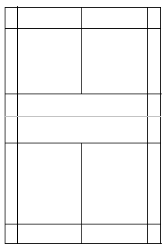

X

Key

X = player
----- = shuttle movement
= target area

Drill description
- Player stands in position (as shown on diagram) and serves over the net into the target area.

Drill 3: High singles serve

X

Key

X = player
----- = shuttle movement
= target area

Drill description
- Player stands in position (as shown on diagram) and serves over the net into the back tramline area (target area).

Drill 4: Forehand flick serve
Drill 5: Backhand flick serve

X

Key

X = player
----- = shuttle movement
= target area

Drill description
- Player stands in position (as shown on diagram) and serves over the net into the target area.

Drill 6: Forehand drive Drill 7: Backhand drive

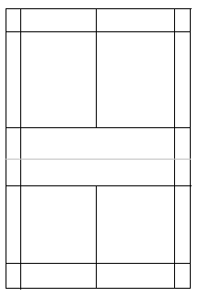
X
O
X
O

Key

X = player
O = feeder
→ = player movement
----- = shuttle movement
= target area

Drill description
- Feeder throws the shuttle fast, straight and shoulder height over the net and down the tramlines.
- Player steps towards the oncoming shuttle and returns it with a fast, flat shot to land in the target area on the diagram.

Drill 8: Forehand and backhand underarm net tumble

X
X

Key

X = player
O = feeder
→ = player movement
----- = shuttle movement

Drill description
- Two players on court standing on the front service line rallying, playing underarm net shots using forehand and backhand strokes.
- Shuttle to stay low over the net and as close to the net as possible, i.e. ‘tumbling’ over.

Drill 9: Forehand net attack shot

O
X

Key

X = player
O = feeder
----- = shuttle movement

Drill description
- Feeder hits an underarm shot from mid-court, keeping it low as it passes over the net.
- Player stands on front service line and quickly hits the shuttle in a downward direction.

Drill 10: Forehand overhead clear Drill 11: Backhand overhead clear

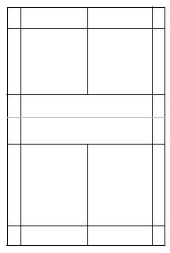
X
O

O

X

Key

X = player
O = feeder
→ = player movement
----- = shuttle movement
= target area

Drill description
- Feeder serves high, aiming to get the shuttle deep, then holds racquet up using an extended arm.
- Player is positioned towards the back of the court, moves forward, and hits an overhead clear so shuttle lands in the target area.
- Shuttle must go over the feeder’s racquet.

Drill 12: Forehand underarm clear Drill 13: Backhand underarm clear

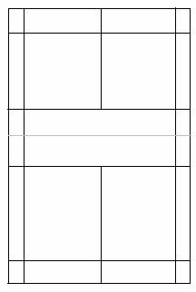
X
O

O

X

Key

X = player
O = feeder
→ = player movement
----- = shuttle movement
= target area

Drill description
- Feeder throws the shuttle in a downward direction mid-court, near the side tramline.
- Player moves forward and hits an underarm clear so shuttle lands in the target area.

Drill 14: Forehand smash

X
O

Key

X = player
O = feeder
→ = player movement
----- = shuttle movement
= target area

Drill description
- Feeder serves high to mid-court area.
- Player steps forward and smashes shuttle toward feeder or into the target area.

Drill 15: Forehand overhead drop shot

X
O

Key

X = player
O = feeder
→ = player movement
----- = shuttle movement
= target area

Drill description
- Feeder serves high to the baseline.
- Player slices or pushes the shuttle downwards so it lands in the target area.

Drill 16: Backhand overhead clear, backhand drive, backhand underarm net tumble

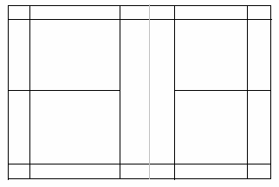
3

O₂
O₁
X
1
2
4
5
6

Key

X = player
O = feeder
→ = player movement
----- = shuttle movement

Drill description Two feeders, one player (starting positions shown on diagram).
- Feeder 1 serves high and deep into the backhand corner.
- Player steps across and returns with a backhand overhead clear to the baseline.
- Feeder 2 throws a shuttle fast and flat down the tramline.
- Player moves forward and returns with a backhand drive down the tramlines.
- Feeder 2 throws a shuttle low over the net.
- Player moves in and plays a backhand underarm ‘tumble’ net shot.

Drill 17: Backhand overhead clear, backhand underarm net tumble, forehand smash

X
O
3
1
2
4
5
6

Key

X = player
O = feeder
→ = player movement
----- = shuttle movement

Drill description
- Feeder hits high serve to the baseline.
- Player hits a backhand overhead clear.
- Feeder hits a drop shot.
- Player hits a backhand net tumble.
- Feeder plays an underarm clear.
- Player smashes.

Drill 18: Forehand drive, forehand overhead clear, forehand underarm net tumble shot

4
3
1
2
5
6
O
O2
X

Key

X = player
O = feeder
→ = player movement
----- = shuttle movement

Drill description
- Feeder 1 throws fast, flat shuttle down the tramlines.
- Player moves across and plays a forehand drive.
- Feeder 2 serves high to the baseline.
- Player moves to the baseline and hits a forehand overhead clear straight down the line.
- Feeder 1 throws shuttle low over the net.
- Player moves into the net returning with a forehand underarm net tumble.

Drill 19: Forehand low serve, backhand underarm clear, backhand overhead clear
X
1
2
3
4
5
O

Key

X = player
O = feeder
→ = player movement
----- = shuttle movement

Drill description
- Player hits a forehand low serve.
- Feeder hits a net attack shot down into the backhand tramline area.
- Player steps across and hits a backhand underarm clear to the baseline.
- Feeder returns this with an overhead clear down the line.
- Player moves back and plays a backhand overhead clear.

Drill 20: High singles serve, backhand overhead cross-court drop, forehand smash
X
2
3
4
5
O
1

Key

X = player
O = feeder
→ = player movement
----- = shuttle movement

Drill description
- Player hits a high singles serve.
- Feeder returns with an overhead forehand clear.
- Player hits a backhand overhead crosscourt drop shot.
- Feeder hits a backhand underarm clear to mid-court.
- Player moves back and smashes.

Drill 21: Backhand flick serve, forehand overhead drop shot, forehand underarm net tumble
O
1
2
3
4
5
X

Key

X = player
O = feeder
→ = player movement
----- = shuttle movement

Drill description
- Player hits a backhand flick serve.
- Feeder returns with an overhead clear, deep to the forehand corner.
- Player hits a forehand overhead drop shot down the line.
- Feeder hits a return backhand underarm net tumble.
- Player moves forward and hits a forehand underarm net tumble.

Drill 22: Forehand overhead drop shot, net tumble

2
X
O
1
4
3

Key

X = player
O = feeder
→ = player movement
----- = shuttle movement

Drill description
- Feeder hits a high serve.
- Player returns with a forehand overhead drop shot.
- Feeder returns with a net shot.
- Player returns with a net tumble.
- Feeder continues to repeat routine.

Drill 23: Forehand underarm net tumble, forehand overhead clear, backhand net tumble, backhand overhead clear

O₃
X
O₂
O₁
O₄

Key

X = player
O = feeder
→ = player movement
----- = shuttle movement

Drill description Four feeders – two with racquets and two with shuttles and one player. Starting positions as per diagram.
Aim is to have the player moving to different parts of the court to play four different shots.
- Feeder 1 throws shuttle over the net.
- Player returns with a forehand net tumble.
- Feeder 2 hits a deep serve to the baseline on the forehand side of the court.
- Player returns with a forehand overhead clear deep, back over feeder’s head.
- Feeder 3 throws the shuttle over the net.
- Player moves diagonally and returns with a backhand net tumble.
- Feeder 4 hits a high serve into the backhand corner.
- Player moves straight back and returns with a backhand overhead clear.
- Repeat several times.

Badminton tactical framework

Tactical problems | Off-the-shuttle skills | On-the-shuttle skills
OFFENCE
Setting up an attack opportunity | - Maintain central court position (get back to base) | - Overhead clear – forehand, backhand  - Overhead drop shot – forehand, backhand  - High service  - Flick serve  - Drive – forehand and backhand
Winning the point | - Quick movement to shuttle  - Meeting shuttle early – above net height  - Holding racquet high out in front of body  - Awareness of opponents position  - Anticipation of play | - Smash  - Attacking the serve  - Attacking drop shot  - Control the net with net tumbles  - Net attack shot
DEFENCE
Defending on own side of the net | - Recovery to base with quick footwork  - Holding racquet out in front of body  - Be patient and move to retrieve all shots back into play  - Anticipation of play | - Low service  - Underarm – clear forehand and backhand  - Overhead – clear forehand and backhand  - High service
Defending against an attacking player | - Keep moving to keep rally going  - Be patient  - Play to opponent’s weaknesses  - Re-gain the attack position | - Push shuttle flat (drives)  - Hit shuttle away into furthest corners  - Return the smash with a forehand or backhand underarm clear/ block  - Return the drop shot with net tumble  - Return fast flat drives by meeting shuttle early

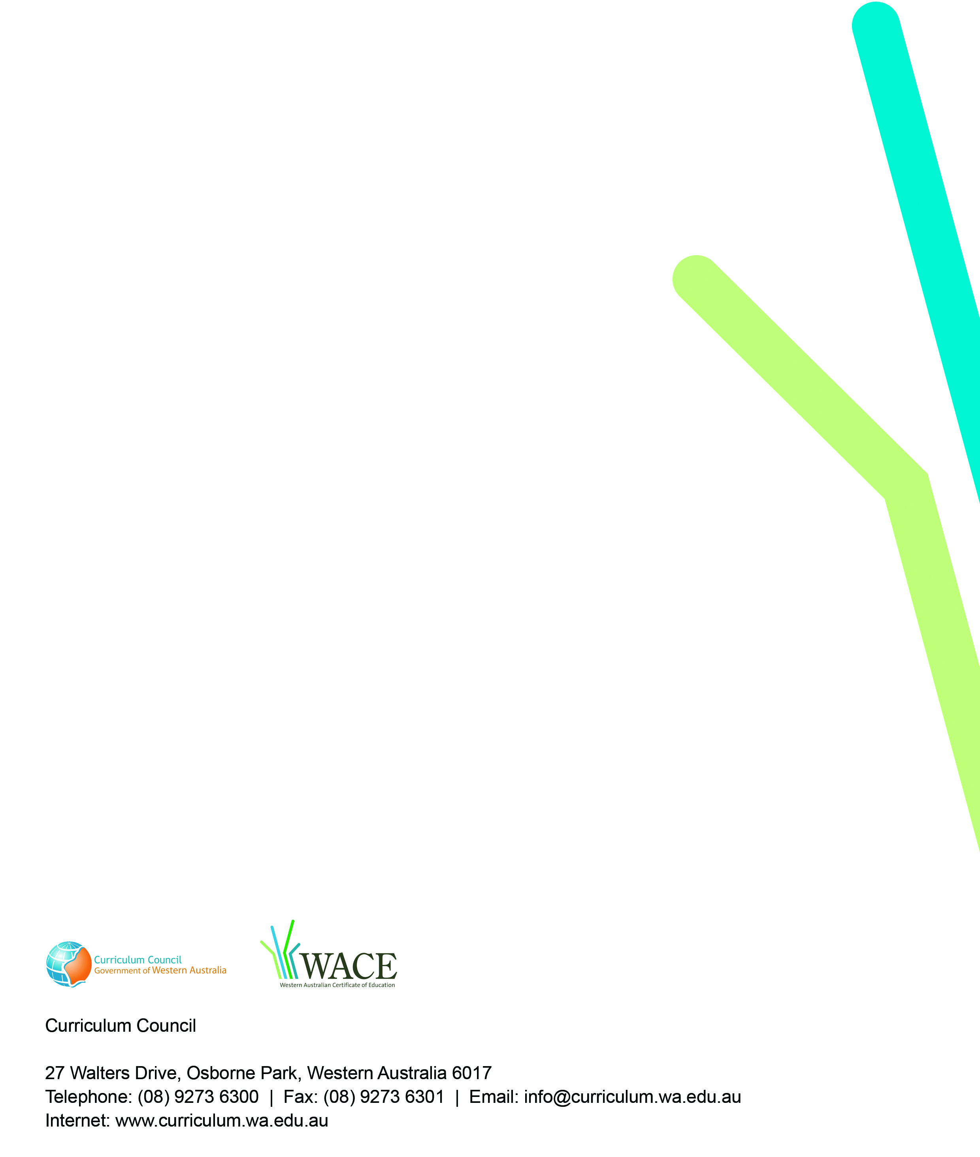
TRIM: 2009/8130[v3]

